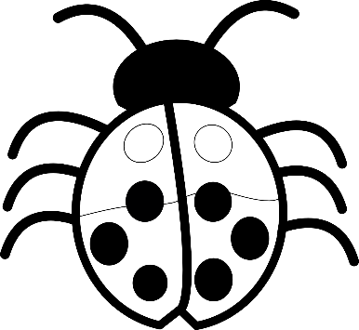
The Arches Children’s Menu Served ~ 11:45-3:00 pm
Home Made Margarita Pizza
Kids Fish and Chips and Peas.
Sausage, Mash and Gravy.
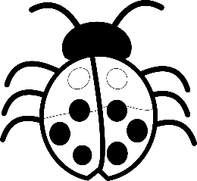
Roast Chicken, Roast Potatoes and Vegetables.
Chicken Nuggets, Chips, Beans or Peas.
£7.95
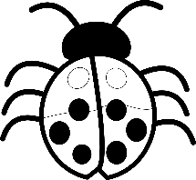
Sandwich, Cheese, Ham, Egg or Tuna and Homemade Crisps, £5.95
Drink included (Juice, Milk or Cordial)
(All Kids Meals made fresh in house).
Kids Ice Cream £2.50
Fruit shoots Various flavours £2.50
