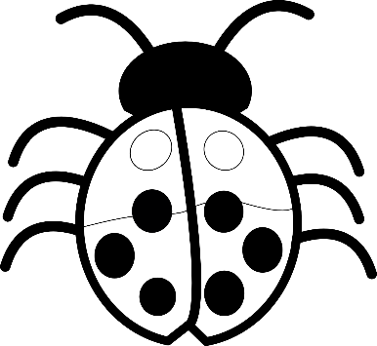
The Arches Children’s Menu
Served 11.45am - 3.00 pm

Cod Goujons, Chips and Peas.
Sausage, Mash and Gravy.
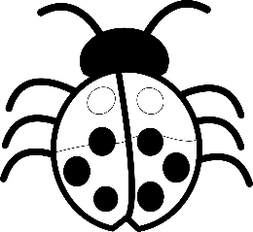
Roast Chicken, Roast Potatoes and Vegetables.
Chicken Nuggets, Chips, Beans or Peas.
All Meals £7.00 (Including Drink)

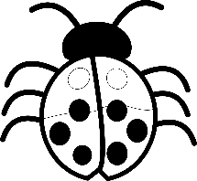
Sandwich - Cheese, Ham or Tuna served with Homemade Crisps.
£5.00 (Including Drink)

Kids Ice Cream £2.25
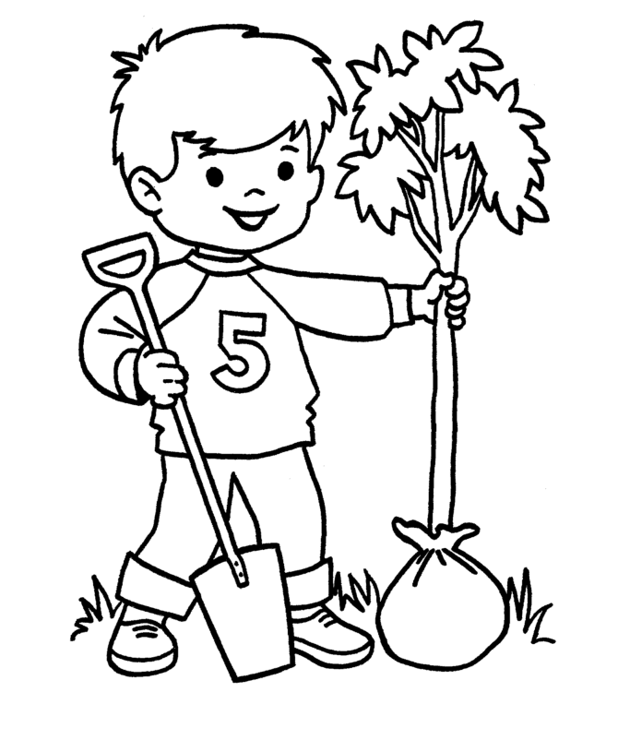
(All Kids Meals made fresh in house).

